CPU SCHEDULING SIMULATOR

21CSC203P / ADVANCED PROGRAMMING PRACTICE
PROJECT REPORT
Submitted by
MUSANI LIKITH REDDY - RA2511028020082
SURYANSHU ROY - RA2511028020093
ADITYA KUMAR SINGH - RA2511028020094
Under the guidance of
DR.P.M.SURESH
(Assistant Professor, Department of Computer Science and Engineering)
in partial fulfilment for the award of the degree of
BACHELOR OF TECHNOLOGY
in
COMPUTER SCIENCE AND ENGINEERING
of
FACULTY OF ENGINEERING AND TECHNOLOGY

SRM INSTITUTE OF SCIENCE AND TECHNOLOGY
RAMAPURAM, CHENNAI - 600089

SRM INSTITUTE OF SCIENCE AND TECHNOLOGY
(Deemed to be University U/S 3 of UGC Act, 1956)
BONAFIDE CERTIFICATE
Certified that this project report titled CPU SCHEDULING SIMULATOR is the bonafide work of Musani Likith Reddy (RA2511028020082), Suryanshu Roy (RA2511028020093) and Aditya Kumar Singh (RA2511028020094) who carried out the project work under my supervision. Certified further, that to the best of my knowledge the work reported herein does not form any other project report or dissertation on the basis of which a degree or award was conferred on an occasion on this or any other candidate.

SIGNATURE  DR.P.M.SURESH  Assistant Professor Department of Computer Science and Engineering w/s Cloud Computing & Big Data Analytics,  SRM Institute of Science and Technology,  Ramapuram, Chennai. |  | SIGNATURE  DR.A.UMAMAGESHWARI  Professor and Head  Department of CC&BDA,  SRM Institute of Science and Technology,  Ramapuram, Chennai.

Submitted for the project viva-voce held on ____________________ at SRM Institute of Science and Technology, Ramapuram, Chennai.

SRM INSTITUTE OF SCIENCE AND TECHNOLOGY
RAMAPURAM, CHENNAI
DECLARATION
We hereby declare that the entire work contained in this project report titled CPU SCHEDULING SIMULATOR has been carried out by Musani Likith Reddy (RA2511028020082), Suryanshu Roy (RA2511028020093) and Aditya Kumar Singh (RA2511028020094) at SRM Institute of Science and Technology, Ramapuram, Chennai, under the guidance of DR.P.M.SURESH, Department of Computer Science and Engineering w/s Cloud Computing & Big Data Analytics.

PLACE: CHENNAI
DATE:
______________________

ABSTRACT
The CPU Scheduling Simulator is a browser-based learning tool that makes the behaviour of operating-system scheduling policies visible. A user builds a workload of processes or jobs, each described by an arrival time, burst time, priority and deadline, and runs it under nine scheduling algorithms: First Come First Served (FCFS), Shortest Job First (SJF), Shortest Remaining Time First (SRTF), Round Robin (RR), Priority scheduling (non-preemptive and preemptive), Multi-Level Feedback Queue (MLFQ), Earliest Deadline First (EDF) and a Completely Fair Scheduler (CFS) style policy. A tick-by-tick simulation engine produces Gantt charts, per-process lifecycle swim-lanes and the standard metrics (completion, turnaround, waiting and response time, CPU utilization and throughput), and a comparison mode runs every algorithm on the same workload side by side.
The application has an HTML, CSS and JavaScript front end and a FastAPI back end with SQLAlchemy persistence. It adds account sign-up and login with salted PBKDF2 password hashing and JWT access tokens, user profiles and saved workspaces, a two-level model in which a long-term job scheduler admits jobs to the short-term CPU scheduler, CSV and JSON import and export, and a program runner that measures local Python, C and C++ programs and uses the measured run time as the burst of a simulated process. On the default five-process workload, SRTF and EDF gave the lowest average waiting time (4.8 time units), while Round Robin with a quantum of 2 gave a higher average waiting time (9.4) but a much better average response time (2.8 against 7.4 for FCFS), which shows the trade-offs the tool is designed to expose.

TABLE OF CONTENTS
Content Page No.
ABSTRACT iv
LIST OF FIGURES vi
LIST OF ACRONYMS AND ABBREVIATIONS vii
CHAPTER 1 INTRODUCTION 1
1.1 Introduction 5
1.2 Problem Statement 5
1.3 Objectives 5
1.4 Scope and Motivation 6
CHAPTER 2 EXISTING SYSTEM 7
CHAPTER 3 PROPOSED METHODOLOGY 8
3.1 Block Diagram 8
3.2 Entity Relationship Diagram 8
3.3 Data Flow Diagram (DFD) 9
3.4 Tools and Technologies 10
CHAPTER 4 IMPLEMENTATION 11
4.1 Back End and REST API 11
4.2 Authentication and Data Storage 11
4.3 Scheduling Engine 12
4.4 Job Scheduler and Program Runner 13
4.5 Front End and Visualization/User Interface 14
CHAPTER 5 RESULT AND DISCUSSION 21
5.1 Test Workload and Configuration 21
5.2 Results 21
5.3 Discussion 22
5.4 Case Study 23
CHAPTER 6 CONCLUSION 25
REFERENCES 26

LIST OF FIGURES
Figure No. | Title | Page No.
Fig 3.1 | Block diagram of the CPU Scheduling Simulator | 4
Fig 3.2 | Entity relationship diagram of the database | 5
Fig 3.3 | Data flow diagram of the system | 6
Fig 4.1 | Account sign-in page of the application | 10
Fig 5.1 | Simulator screen showing the process queue in demo mode | 11
Fig 5.2 | Average waiting, turnaround and response time for the nine algorithms | 12
Fig 5.3 | Gantt charts for FCFS, SRTF and Round Robin on the default workload | 12

LIST OF ACRONYMS AND ABBREVIATIONS
Acronym Expansion
API Application Programming Interface
CFS Completely Fair Scheduler
CPU Central Processing Unit
CRUD Create, Read, Update, Delete
CS Context Switch
CSS Cascading Style Sheets
CSV Comma-Separated Values
DFD Data Flow Diagram
EDF Earliest Deadline First
ER Entity Relationship
FCFS First Come First Served
HTML Hyper Text Markup Language
JSON JavaScript Object Notation
JWT JSON Web Token
MLFQ Multi-Level Feedback Queue
NP Non-Preemptive
ORM Object Relational Mapping
OS Operating System
PBKDF2 Password-Based Key Derivation Function 2
PCB Process Control Block
REST Representational State Transfer
RR Round Robin
RT Response Time
SJF Shortest Job First
SQL Structured Query Language
SRTF Shortest Remaining Time First
TAT Turnaround Time
UI User Interface
WT Waiting Time

CHAPTER 1 INTRODUCTION

1.1 Introduction
An operating system shares one processor among many competing processes, and the CPU scheduler decides which process runs next. This decision changes how long each process waits, how quickly it first responds, how fully the processor is used and whether time-critical work meets its deadline. Scheduling is therefore a core topic of any operating systems course, and it is usually taught through algorithms such as FCFS, SJF, Round Robin and priority scheduling.
This project is the CPU Scheduling Simulator, a browser-based tool in which a user defines a workload, selects a scheduling policy and watches the processor timeline unfold. It implements nine classic and modern policies in one tick-accurate engine, draws the result as Gantt charts, computes per-process and aggregate metrics, and lets the user compare policies on identical input. A FastAPI back end adds accounts, profiles, saved workspaces, workload generation and the ability to run real source programs and use their measured run times as process bursts.

1.2 Problem Statement
Scheduling policies are easy to describe in theory but hard to compare without seeing processes compete for CPU time. Arrival times, burst lengths, priorities and deadlines interact, so a policy that helps one workload can delay another. Students normally draw Gantt charts by hand for a handful of processes, which is slow, error-prone and does not scale to experiments such as changing the quantum or adding context-switch cost.
The problem addressed by this project is to build an interactive simulator that runs several scheduling policies against an editable workload, shows the resulting execution order, and reports measurable performance metrics so that the policies can be compared objectively.

1.3 Objectives
The objectives of the project are:
- To implement FCFS, SJF, SRTF, Round Robin, Priority (non-preemptive and preemptive), MLFQ, EDF and CFS in a single tick-by-tick engine that supports preemption, a configurable time quantum, context-switch overhead and a choice of priority convention.
- To visualize execution through synchronized Gantt views, a ready-queue and process-state monitor, and per-process lifecycle swim-lanes.
- To compute completion, turnaround, waiting and response time, CPU utilization and throughput, and to compare all algorithms on the same workload.
- To model long-term job admission feeding the short-term CPU scheduler in one synchronized simulation.
- To accept realistic input: manual entry, generated workloads (uniform, Poisson and exponential), CSV or JSON import, and measured Python, C and C++ programs.
- To provide accounts, profiles, workspaces, saved runs, system logs, CSV and JSON export, a dark theme and accessibility options.

1.4 Scope and Motivation
The simulator models a single CPU that runs one process at a time in discrete time units. A process moves through the New, Ready, Running and Terminated states, and context switches can be given a cost. Input and output bursts, memory management and multi-core scheduling are outside the scope of the current version, and the generated workloads are limited to 1 to 20 processes.
The motivation is educational. Seeing the same workload scheduled under different policies, and changing one parameter at a time, helps students move from memorizing definitions to understanding trade-offs such as the convoy effect under FCFS, starvation under SJF and priority scheduling, and the dependence of Round Robin on its quantum. The tool is also a practical software project that combines a web front end, a REST API, authentication and a relational database.

CHAPTER 2 EXISTING SYSTEM
In most courses CPU scheduling is introduced through textbook examples. The instructor or the textbook presents a small table of processes, applies an algorithm by hand and draws a Gantt chart on the board or on paper. Averages are then calculated manually from the chart. Some online animations exist, but they typically show one algorithm at a time on a fixed example.
The limitations of this approach are:
- The charts are static. A student cannot change an arrival time, burst or quantum and immediately see the effect.
- Hand calculation is slow and error-prone, especially for preemptive policies such as SRTF, Round Robin and MLFQ.
- Policies are examined one at a time, so comparing them on the same workload requires repeating the whole exercise.
- Parameters such as context-switch cost, priority convention and MLFQ quanta are rarely explored.
- Workloads are small and invented. There is no way to feed in the run time of a real program.
- Nothing is saved, exported or shared, and there is no notion of a long-term job scheduler feeding the CPU scheduler.

CHAPTER 3 PROPOSED METHODOLOGY

3.1 BLOCK DIAGRAM
The system has three tiers, shown in Fig 3.1. The browser client holds the user interface and the scheduling engine, so a simulation runs instantly in the browser without a server round trip. The FastAPI service exposes versioned REST endpoints for authentication, profiles, workspaces, logs, saved simulations and workload generation, and hosts the program runner. SQLAlchemy connects the service to the SQL database. The program runner compiles and executes selected source files in a temporary workspace using the local Python interpreter, gcc and g++.
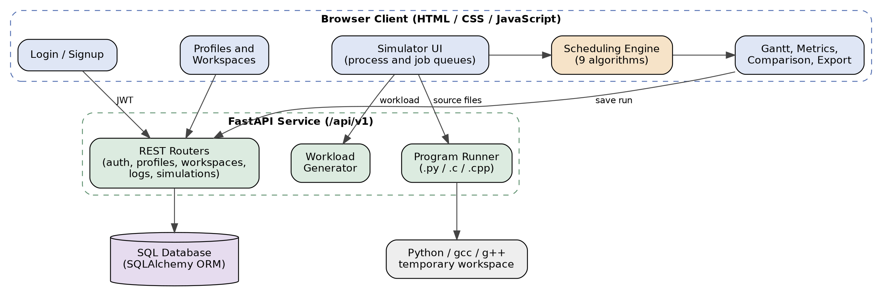
Fig 3.1 Block diagram of the CPU Scheduling Simulator

3.2 ENTITY RELATIONSHIP DIAGRAM
The database stores accounts, profiles, workspaces and saved simulation results (Fig 3.2). A profile owns many workspaces, photos and log entries. A workspace stores the algorithm settings (algorithm, quantum, context-switch cost, priority convention, job policy, job capacity and MLFQ quanta) together with its process and job queues. A saved simulation result belongs to a workspace and has many process rows and many Gantt segments. The users table holds registered accounts for sign-in and is independent of the profile tables. Child rows are deleted with their parent (cascade), except that log entries are kept with a null profile if the profile is removed.
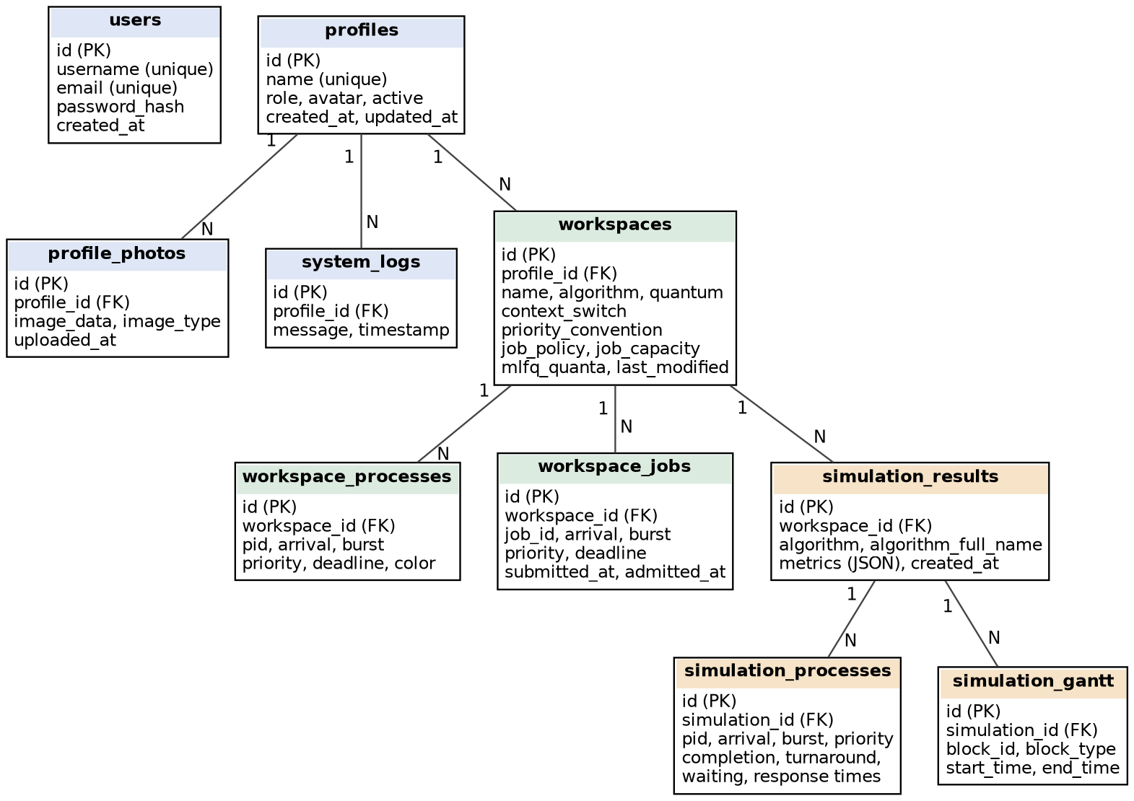
Fig 3.2 Entity relationship diagram of the database

3.3 DATA FLOW DIAGRAM (DFD)
Fig 3.3 shows how data moves through the system. The user is authenticated (process 1.0) against the users store, which keeps only password hashes. Profile and workspace requests (2.0) read and write the profile and workspace store. The workload builder (3.0) places manual, generated, imported or program-derived processes into the process and job queues. The simulation process (4.0) reads the queue and the algorithm settings, produces the Gantt timeline and metrics, saves them as simulation results and records events in the system log. The analysis process (5.0) presents charts and tables and exports CSV or JSON files.
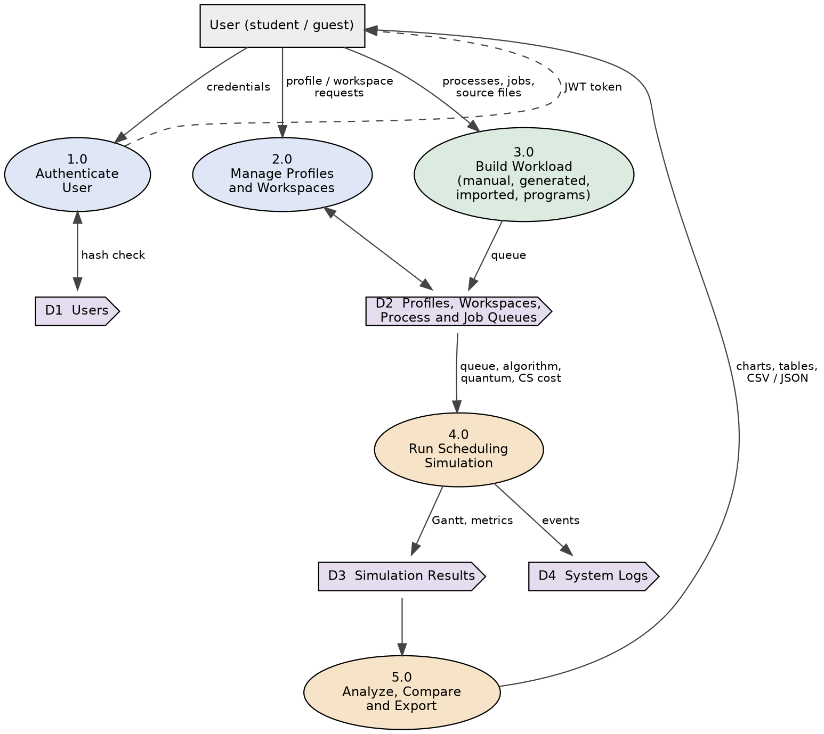
Fig 3.3 Data flow diagram of the system

3.4 TOOLS AND TECHNOLOGIES
Table 3.1 lists the tools and technologies used. Version numbers are those pinned in the project requirements file.
Table 3.1 Tools and technologies
Technology | Version | Purpose
HTML5, CSS3, JavaScript | - | Simulator, login, profile and workspace pages; scheduling engine; Gantt rendering
Python | 3.13 / 3.14 (as used) | Back-end language and interpreter for .py program runs
FastAPI | 0.109.0 | REST API, static file serving, automatic request validation
Uvicorn | 0.27.0 | ASGI server that runs the application
Pydantic | 2.5.3 | Request and response schemas
SQLAlchemy | 2.0.25 | ORM and database session management
PyMySQL / MySQL | 1.1.0 | Default relational database (configurable through DATABASE_URL)
python-jose | 3.3.0 | Creation and verification of JWT access tokens
hashlib (PBKDF2) | standard library | Salted password hashing
python-dotenv | 1.0.0 | Loading settings from an environment file
gcc and g++ | system installed | Compiling C and C++ programs for the program runner
Git and GitHub | - | Version control and project hosting

CHAPTER 4 IMPLEMENTATION

4.1 BACKEND AND REST API
The FastAPI application (Backend/main.py) enables CORS, creates the database tables at start-up, serves the sign-in page at the root URL, the workspace page at /workspace and the simulator at /simulator, mounts the Frontend folder as static files, and includes the /api/v1 router. Interactive API documentation is exposed only when DEBUG is enabled. Each feature has its own router module with matching schema, model and CRUD modules, which keeps request validation, persistence and business logic separate. Table 4.1 summarizes the endpoint groups.
Table 4.1 REST endpoint groups under /api/v1
Group | Operations
/auth | POST signup; POST token (login); POST forgot-password; POST reset-password; GET account; GET me
/profiles | List, read, create, rename and delete profiles; activate a profile; upload, fetch and delete a profile photo
/workspaces | List, read, create, update and delete workspaces; add processes; add jobs; save; export
/simulations | Create a saved run; read one run or all runs of a workspace; store metrics; export a run as CSV or JSON
/logs | List, add, clear and export system log entries
/workload | GET a synthetic workload: count 1 to 20, distribution uniform, poisson or exponential, lambda and maximum burst
/programs/run | POST a Python, C or C++ source file to be run and timed

BACKEND ACTIVATION:
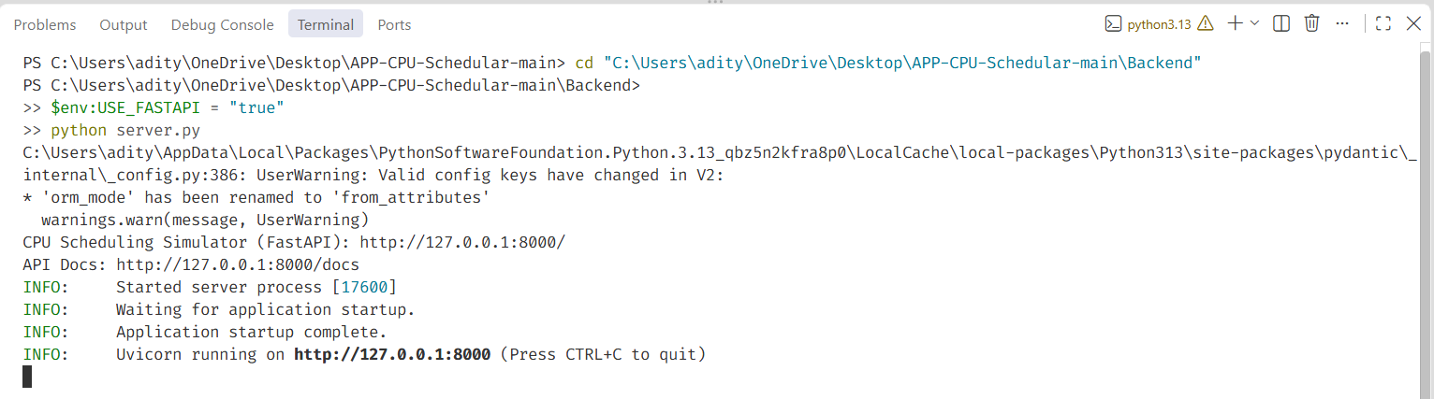

4.2 AUTHENTICATION AND DATA STORAGE
Sign-up requires a unique username of 3 to 50 characters, a unique email address and a password of at least 8 characters. Passwords are never stored in readable form. The back end generates a random 16-byte salt for each password and derives a 32-byte key with PBKDF2-HMAC-SHA-256 using 310,000 iterations. The stored value has the form pbkdf2_sha256$salt$key. At login the derivation is repeated with the stored salt and compared with the stored key using a constant-time comparison, so identical passwords produce different stored values. A successful login returns a JWT signed with HS256; the access token expires after 15 minutes by default. Password recovery e-mails a reset link that expires after 30 minutes and needs SMTP settings.
Database access goes through SQLAlchemy models. The connection string is read from the DATABASE_URL setting, with a MySQL database named cpu_scheduling as the default. Saved simulations keep the metrics as JSON together with one row per process and one row per Gantt segment, so a past run can be reloaded or exported exactly as it was produced.

4.3 SCHEDULING ENGINE
The engine is the function simulate() in Frontend/app.js. It advances a clock one time unit at a time. Each process is held as a process control block (PCB) that records the remaining burst, state, response time, completion time, virtual runtime, MLFQ queue level and a tick-by-tick history used for the swim-lanes. In every tick the engine admits new arrivals, handles a context switch if one is in progress, checks whether the running process must be preempted, selects the next process, executes one unit and records completion. The result contains the Gantt segments, state snapshots for playback, the PCBs and the makespan. Table 4.2 gives the selection rule for each algorithm.
Table 4.2 Selection and preemption rules
Algorithm | Mode | Rule used by the engine
FCFS | Non-preemptive | Smallest arrival time; ties broken by process id
SJF | Non-preemptive | Smallest total burst; ties by arrival
SRTF | Preemptive | Smallest remaining time; preempts when a ready process has less remaining time
Round Robin | Preemptive | FIFO queue; the running process is moved to the back after its quantum Q
Priority (NP) | Non-preemptive | Best priority value (lower number is higher priority by default, configurable)
Priority (P) | Preemptive | As above, but a newly ready process with better priority preempts
MLFQ | Preemptive | Three queues with quanta 2, 4 and 8; a process that uses its quantum is demoted; waiting processes are promoted after 20 ticks of aging
EDF | Preemptive | Earliest absolute deadline; preempts when a ready process has an earlier deadline
CFS | Preemptive | Smallest virtual runtime; vruntime grows by one for each tick a process runs

The preemption test is a single switch on the algorithm. The excerpt below is taken from the project source.
function shouldPreempt() {
if (!current) return false;
const pool = readyPool();
if (!pool.length) return false;
switch (algo) {
case 'fcfs': case 'sjf': case 'priority_np': return false;
case 'rr': return current.quantumUsed >= Q;
case 'srtf': return pool.some(p => p.remaining < current.remaining);
case 'priority_p': return pool.some(p => p.priority * priMul < current.priority * priMul);
case 'mlfq': {
for (let q = 0; q < current.queueLevel; q++) if (fifoQ[q].length) return true;
return current.quantumUsed >= mlfqQ[current.queueLevel];
}
case 'edf': return pool.some(p => (p.deadline ?? Infinity) < (current.deadline ?? Infinity));
case 'cfs': return pool.some(p => p.vruntime < current.vruntime);
default: return false;
}
}

When a context-switch cost is configured, the engine inserts that many CS ticks into the Gantt chart whenever the CPU changes from one process to another, and the ticks count as busy time that does no useful work. Idle ticks are shown as IDLE. The metrics are calculated in calcMetrics() as follows (Table 4.3).
Table 4.3 Metric definitions
Metric | Definition
Turnaround time (TAT) | Completion time - arrival time
Waiting time (WT) | Turnaround time - burst time
Response time (RT) | Time of first execution - arrival time
CPU utilization | Total burst / (makespan - earliest arrival), as a percentage
Throughput | Completed processes / makespan

4.4 JOB SCHEDULER AND PROGRAM RUNNER
The simulator models two levels of scheduling. Jobs are submitted to a job pool, and a long-term policy with a configurable capacity admits them to the ready queue, from which the short-term algorithm allocates the CPU. The Gantt chart can show both levels at once.
The program runner (Backend/api/v1/programs.py) lets a user drop up to 10 source files of at most 256 KB each into the process queue. The accepted extensions are .py, .c, .cc, .cpp and .cxx. Python files run with the back end interpreter in isolated mode, and C and C++ files are first compiled with gcc or g++. Compilation has a 10-second timeout and each run a 5-second timeout, standard input is closed, and standard output and error are each limited to 20,000 characters. For every successful run the measured run time is converted to a burst of ceil(runtime in ms / 10) units, clamped between 1 and 500, and the process arrives at time 0 with priority 1 and a deadline 10 units after its burst. Failed programs are reported and not queued. The runner accepts requests from the local machine only and executes the files as trusted code; it is not a general-purpose security sandbox.

4.5 FRONTEND AND VISUALIZATION
The simulator page (index.html, app.js, styles.css) contains the process queue, job scheduler, algorithm selector with quantum, context-switch and priority controls, a terminal-style panel for program output and run status, the Gantt chart and the metrics tables. The Gantt chart has three views (dual job and CPU timeline, CPU only, and per-process swim-lanes), three scale modes and playback controls to play, pause, step and seek through time, with tooltips that show the state of the selected process. The comparison panel runs all nine algorithms on the current workload and highlights the best value in each metric column.
Workloads can be typed in, generated with uniform, Poisson or exponential arrivals, or imported from CSV or JSON, and results can be exported as CSV or JSON. The login and signup page (Fig 4.1) offers a link to a guest demo simulator that needs no account. The profile and workspace pages store settings per profile, and a logs page shows application activity. A dark theme and accessibility controls for contrast, text size and zoom are available on every page.

USER INTERFACE:
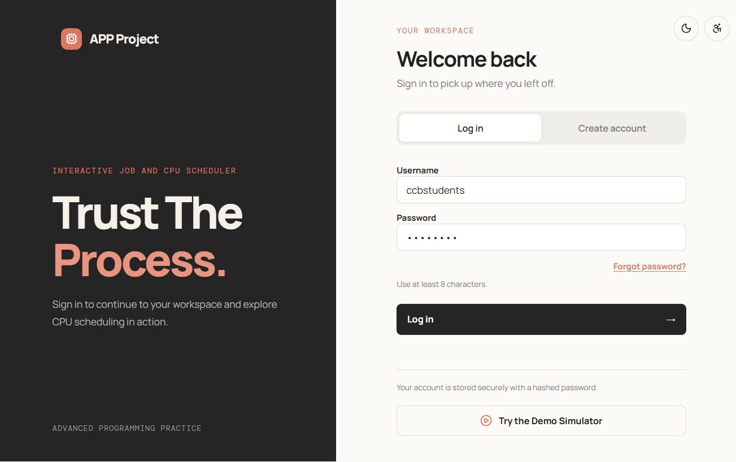

Fig 4.1.1: Account sign-in page of the application
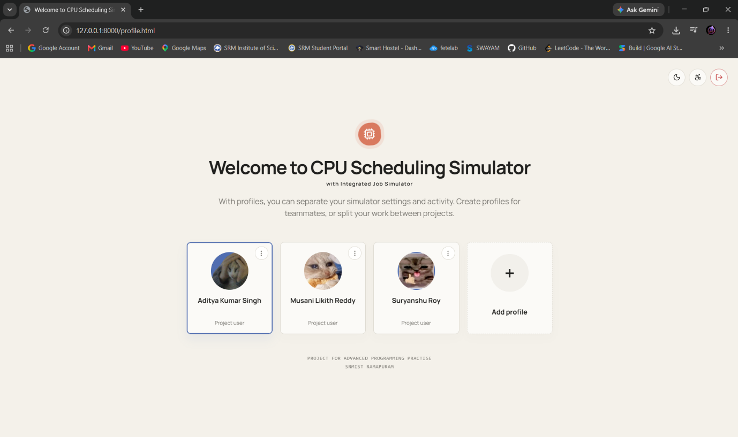
Fig 4.1.2: Profile Page
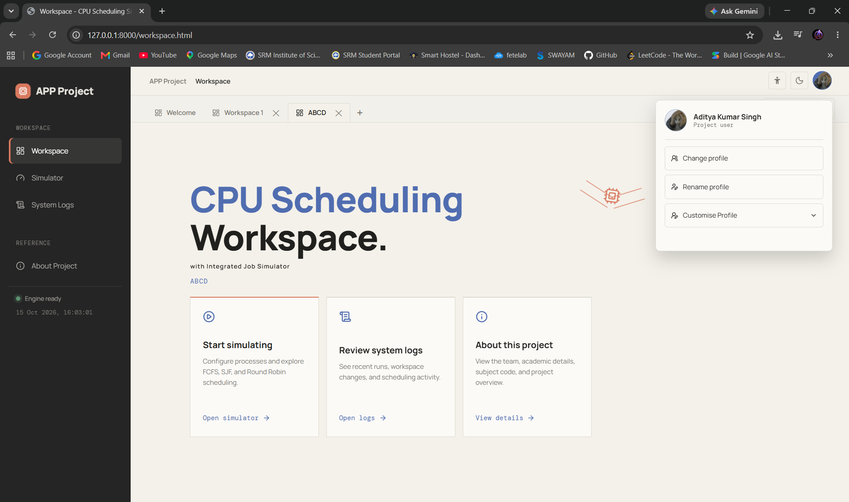
Fig 4.1.3: Workspace

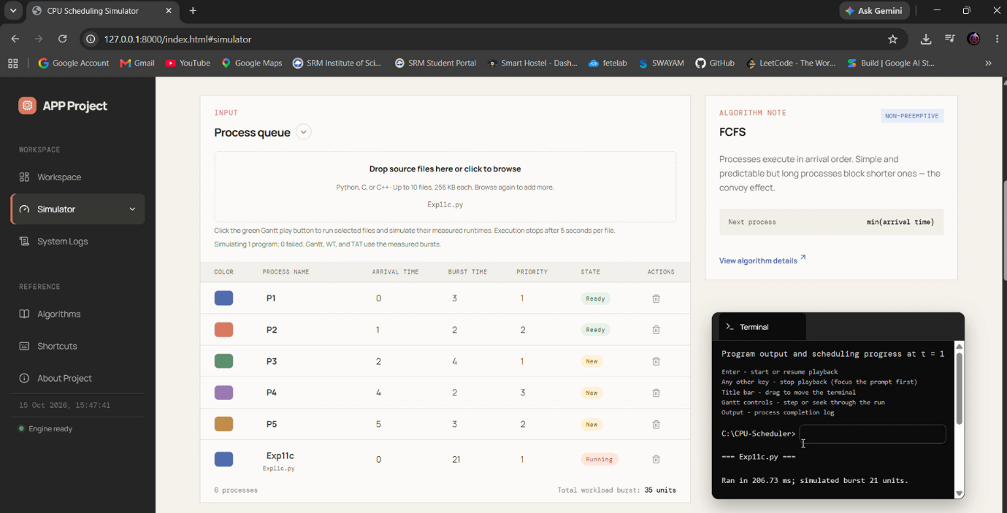

Fig 4.1: Process Queue/Schedular

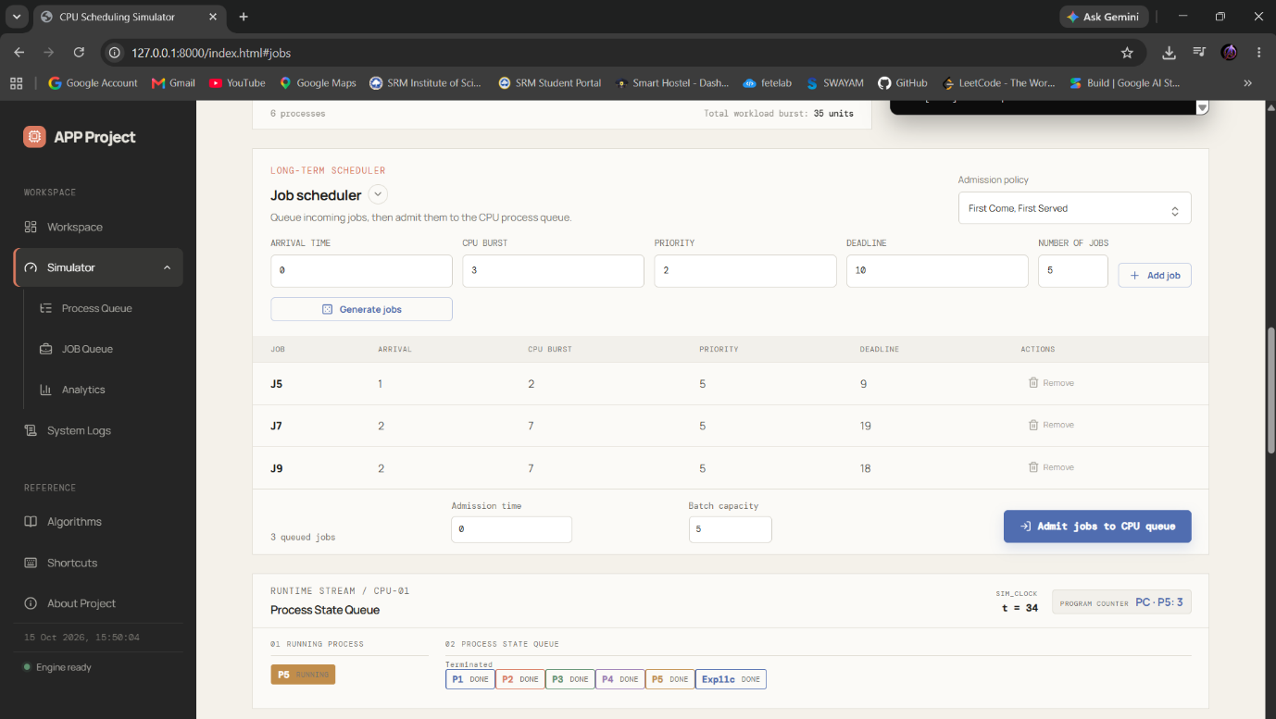

Fig 4.1: Job Queue/Schedular

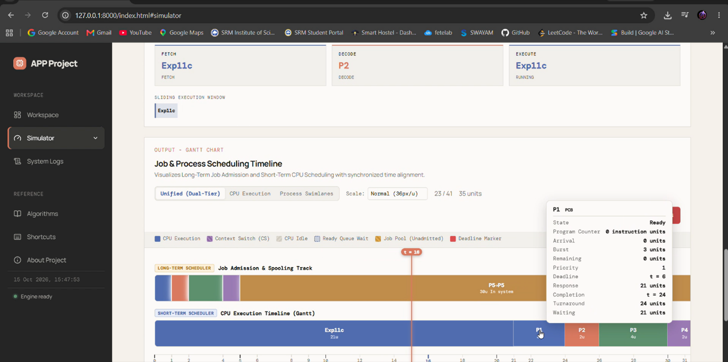
Fig 4.1: Gantt Chart

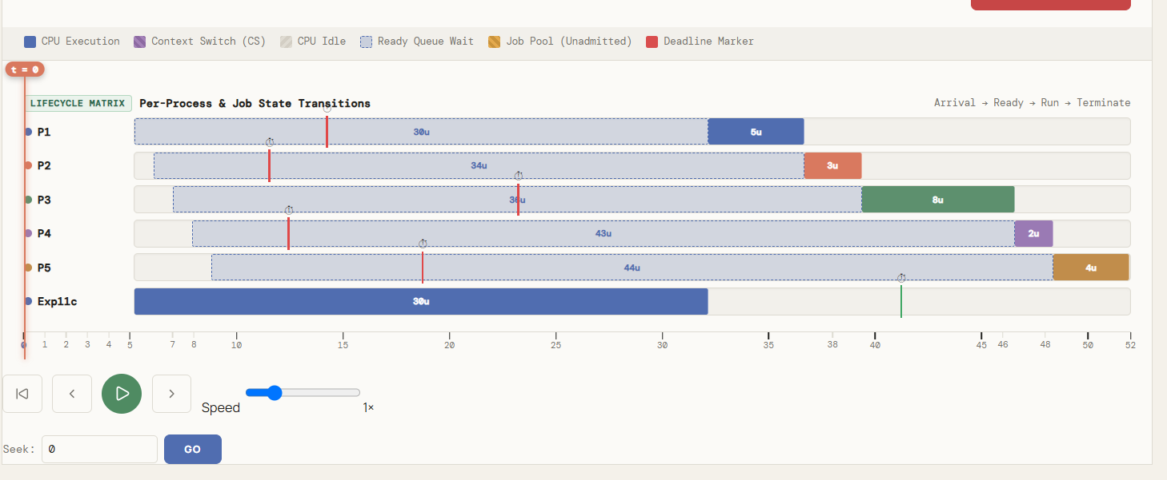

Fig 4.1: Process Swimlanes

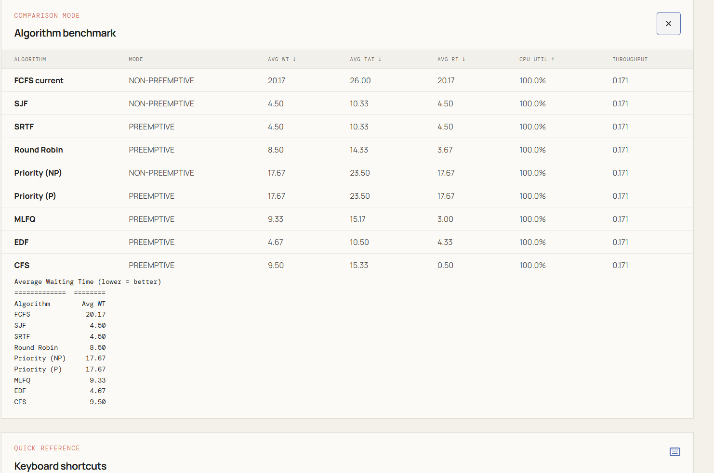

Fig 4.1: Algorithm Benchmark

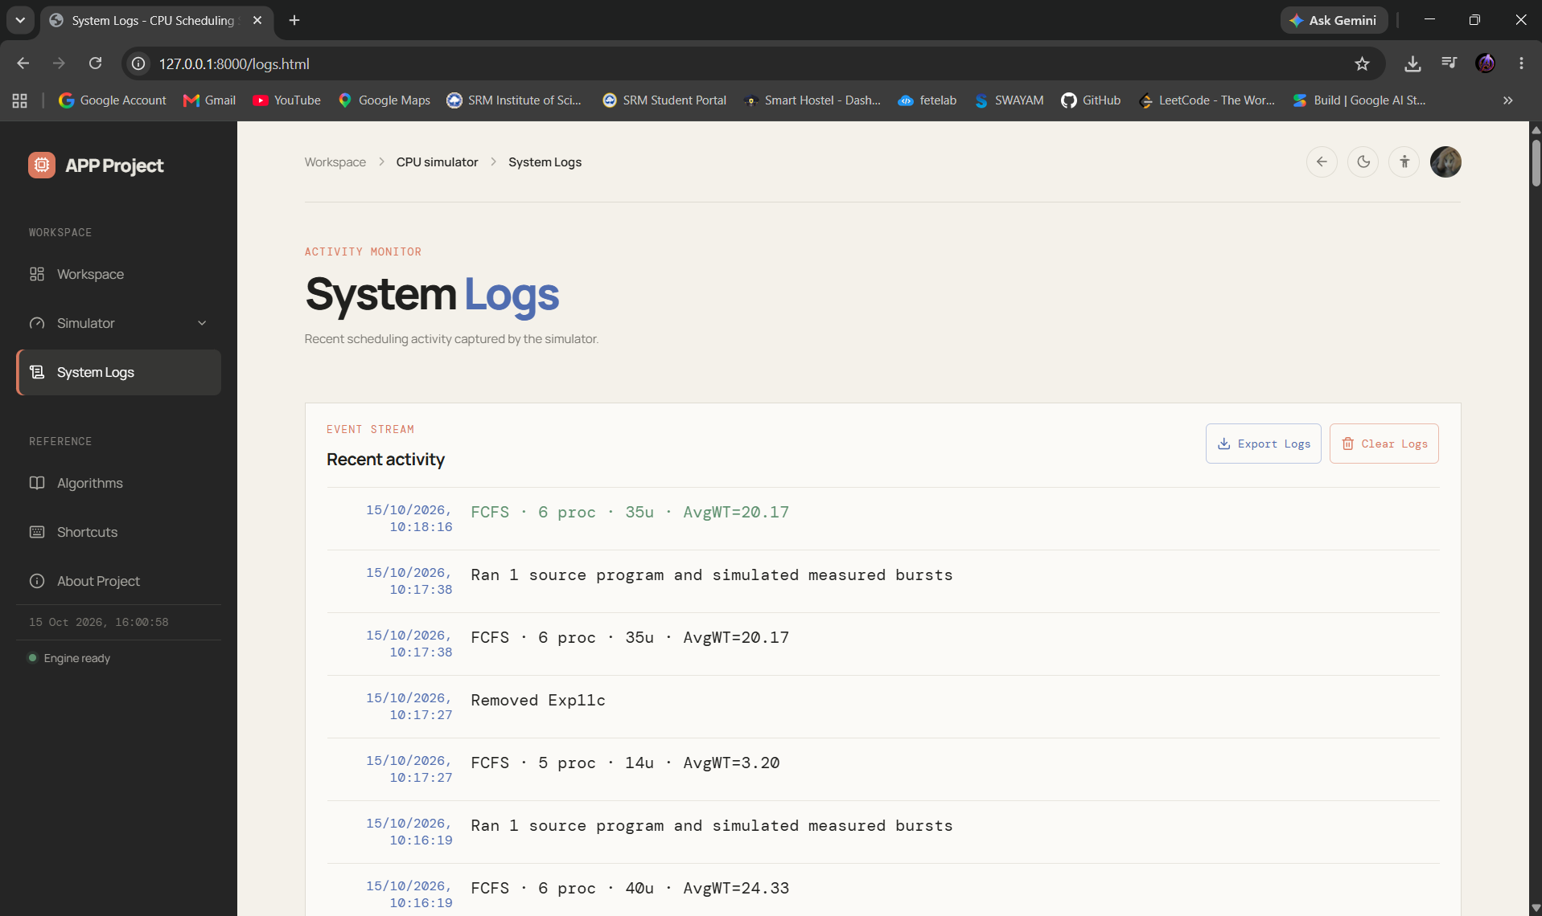

Fig 4.1: System Logs

CODE SNIPPRTS (FRONTEND/BACKEND):

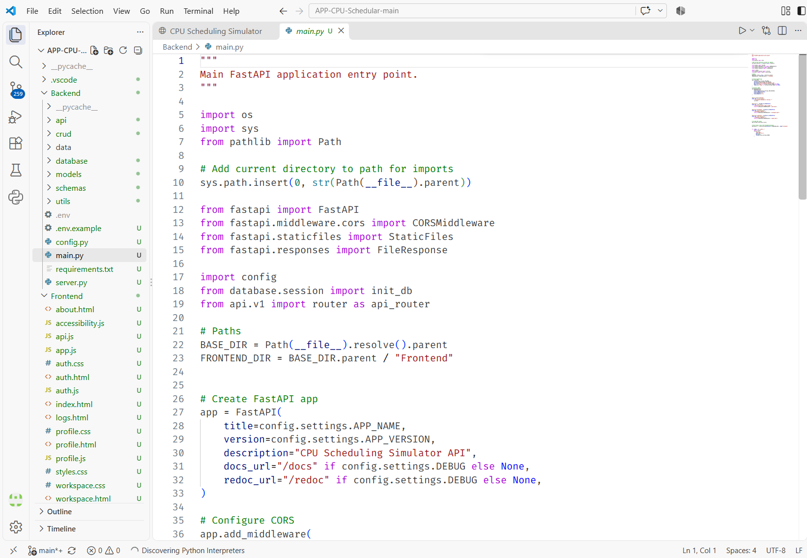

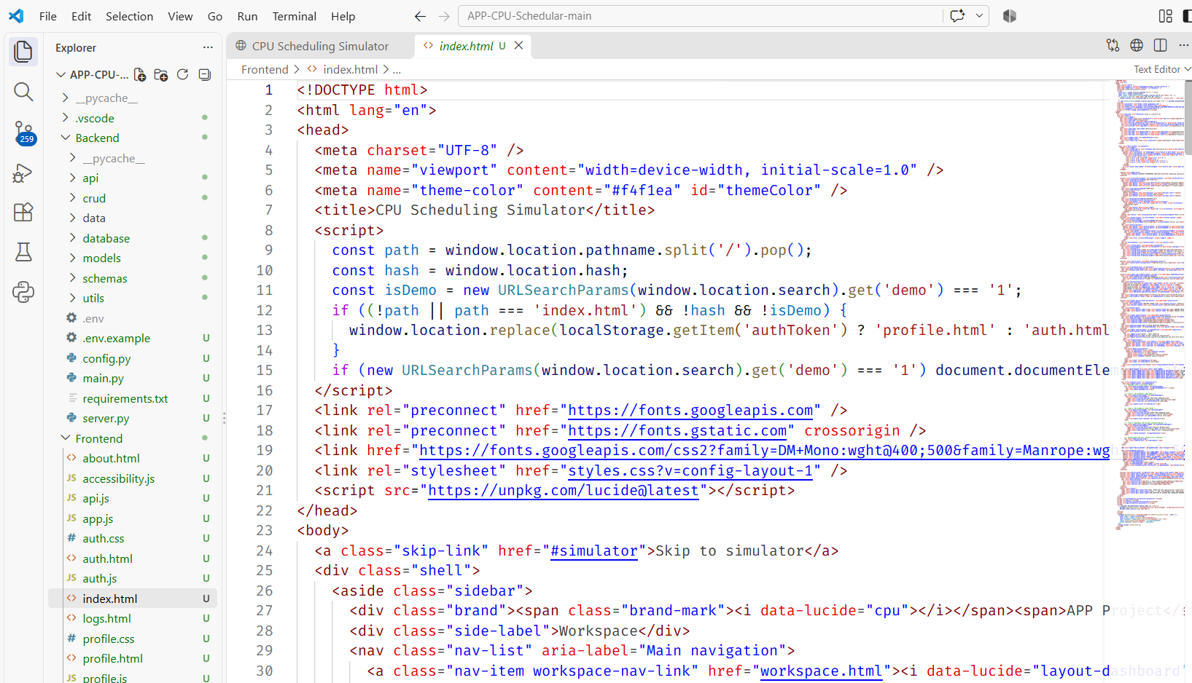

CHAPTER 5 RESULT AND DISCUSSION

5.1 TEST WORKLOAD AND CONFIGURATION
All results were produced by running the simulator engine from the project source (the simulate() and calcMetrics() functions of Frontend/app.js) on the default five-process workload of the application, listed in Table 5.1. The time quantum was 2 units, the context-switch cost 0 and the priority convention lower number means higher priority. The total burst is 22 units and the processor is never idle, so every algorithm finishes at time 22 with 100% utilization and a throughput of 0.227 processes per unit.
Table 5.1 Default workload
Process | Arrival | Burst | Priority | Deadline
P1 | 0 | 5 | 2 | 10
P2 | 1 | 3 | 1 | 7
P3 | 2 | 8 | 3 | 20
P4 | 3 | 2 | 2 | 8
P5 | 4 | 4 | 1 | 15

5.2 RESULTS
Fig 5.1 shows the simulator screen with the process queue. Table 5.2 and Fig 5.2 compare the nine algorithms on the default workload, and Fig 5.3 shows the Gantt charts of three of them. The last column of Table 5.2 counts the processes that finish after their deadline.
Table 5.2 Metrics by algorithm on the default workload (time units)
Algorithm | Avg WT | Avg TAT | Avg RT | CPU util. | Throughput | Missed
FCFS | 7.4 | 11.8 | 7.4 | 100% | 0.227 | 3
SJF | 5.2 | 9.6 | 5.2 | 100% | 0.227 | 2
SRTF | 4.8 | 9.2 | 3.8 | 100% | 0.227 | 1
RR (Q = 2) | 9.4 | 13.8 | 2.8 | 100% | 0.227 | 5
Priority (NP) | 5.8 | 10.2 | 5.8 | 100% | 0.227 | 3
Priority (P) | 5.6 | 10.0 | 4.2 | 100% | 0.227 | 3
MLFQ (2, 4, 8) | 9.0 | 13.4 | 2.0 | 100% | 0.227 | 4
EDF | 4.8 | 9.2 | 3.8 | 100% | 0.227 | 1
CFS | 9.2 | 13.6 | 0.0 | 100% | 0.227 | 4

Fig 5.2 Average waiting, turnaround and response time for the nine algorithms
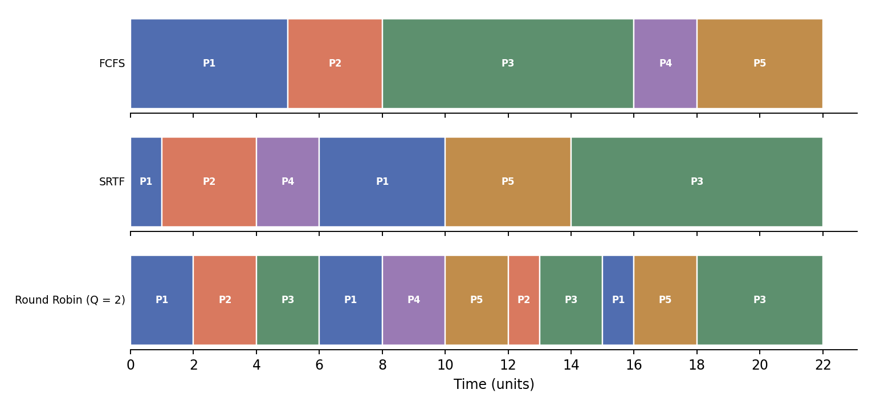
Fig 5.3 Gantt charts for FCFS, SRTF and Round Robin on the default workload

5.3 DISCUSSION
- Waiting and turnaround time. SRTF and EDF gave the lowest average waiting time (4.8) on this workload, followed by SJF (5.2) and the priority policies (5.6 and 5.8). FCFS gave 7.4, and Round Robin, MLFQ and CFS were highest (9.0 to 9.4) because they interleave processes and so delay the long ones.
- Response time. The ordering reverses for responsiveness. Round Robin (2.8), MLFQ (2.0) and CFS (0.0) start every process quickly, while FCFS (7.4) and SJF (5.2) make late arrivals wait for earlier ones to finish.
- Deadlines. The total burst of 22 exceeds the largest deadline (20), so at least one deadline must be missed by any algorithm. EDF and SRTF miss only P3, while Round Robin misses all five.
- Utilization and throughput. These are identical for all nine algorithms here because there is no idle time and no context-switch cost. They become informative once a switch cost is introduced (Section 5.4).
- Longest process. Under every algorithm except FCFS, P3 (the longest process) finishes last, at time 22, after waiting 12 units; under FCFS it waits only 6. Policies that favour short or urgent work push the longest process to the end, and on a longer workload this could become starvation.
- CFS model. Response time is 0 for every process because a new process starts with a virtual runtime of 0 and immediately preempts. This is a property of the simplified fair-share model in the simulator, not of the Linux scheduler, which places new tasks relative to the minimum virtual runtime.

5.4 CASE STUDY
Scenario. A small system runs the five processes of Table 5.1. P3 is a long batch task (burst 8) that arrives early, and P4 is a short interactive task (burst 2) that arrives just after it. The case study uses the simulator to choose a policy and to tune it.
Convoy effect. Under FCFS, P3 runs from time 8 to 16 and P4, which needs only 2 units, does not start until time 16. It waits 13 units, more than six times its own burst. Under SRTF, P4 starts at time 4, as soon as P2 finishes, and waits only 1 unit. Table 5.3 shows the per-process waiting and response times. The average waiting time falls from 7.4 to 4.8 units, a reduction of about 35%, at the price of P1 being preempted and waiting 5 units instead of 0, and P3 waiting 12 instead of 6.
Table 5.3 Per-process waiting time (WT) and response time (RT) in time units
Process | WT FCFS | WT SRTF | WT RR | RT FCFS | RT SRTF | RT RR
P1 | 0 | 5 | 11 | 0 | 0 | 0
P2 | 4 | 0 | 9 | 4 | 0 | 1
P3 | 6 | 12 | 12 | 6 | 12 | 2
P4 | 13 | 1 | 5 | 13 | 1 | 5
P5 | 14 | 6 | 10 | 14 | 6 | 6

Quantum size and context-switch cost. Round Robin needs a quantum. Table 5.4 repeats the run for several quanta, first with free context switches and then with a cost of one time unit per switch. With free switches, a small quantum gives excellent response (average 1.2 at Q = 1) and a large one approaches FCFS (7.4 at Q = 8, identical to FCFS because no process is longer than the quantum). Once a switch costs one unit the picture changes. At Q = 1 the processor spends 14 of 36 units switching, utilization drops to 61.1% and average waiting time rises to 20.8. At Q = 4 utilization recovers to 91.7% while average response time is 6.2, showing the compromise between responsiveness and overhead.
Table 5.4 Round Robin: effect of quantum (Q) and context-switch cost (CS)
Q | WT (CS=0) | RT (CS=0) | WT (CS=1) | RT (CS=1) | Makespan (CS=1) | Util. (CS=1)
1 | 8.8 | 1.2 | 20.8 | 3.6 | 36 | 61.1%
2 | 9.4 | 2.8 | 14.8 | 5.0 | 28 | 78.6%
3 | 8.0 | 4.2 | 10.6 | 5.4 | 26 | 84.6%
4 | 9.0 | 5.0 | 10.8 | 6.2 | 24 | 91.7%
6 | 7.8 | 6.6 | 8.4 | 7.0 | 23 | 95.7%
8 | 7.4 | 7.4 | 7.4 | 7.4 | 22 | 100.0%

Recommendation. For this mixed workload, SRTF (or SJF if preemption is unwanted) minimizes waiting time and fixes the convoy effect, EDF gives the same average waiting time and the fewest missed deadlines and is the natural choice if deadlines matter, and Round Robin with a quantum of about 3 to 4 units is the best choice when interactive response matters and context switches are not free. The conclusions apply to this workload and would need to be re-checked with the simulator on a different one.

CHAPTER 6 CONCLUSION
The CPU Scheduling Simulator meets its objectives. It implements nine scheduling algorithms in one tick-accurate engine, shows execution as Gantt charts and swim-lanes, computes the standard process metrics, and compares policies on identical input. The surrounding application adds secure accounts, profiles and workspaces, saved and exportable runs, a two-level job and process model, and a runner that turns real Python, C and C++ programs into simulated processes.
The results and the case study show the expected trade-offs: SRTF and EDF minimize waiting time and deadline misses on the test workload, Round Robin and MLFQ give the best response, and the benefit of a small quantum disappears once context switches cost time. The tool therefore helps a student move from theory to evidence by changing one parameter and seeing the effect immediately.
The current version has limitations. It simulates one CPU without input and output bursts, the CFS policy is a simplified model, and the program runner executes trusted local files without a sandbox. Possible future work includes multi-core scheduling, I/O bursts and blocked states, additional policies, an isolated execution environment for uploaded programs, and deployment as a shared service for a class.

REFERENCES
1. A. Silberschatz, P. B. Galvin and G. Gagne, Operating System Concepts, 10th ed. Hoboken, NJ: Wiley, 2018.
2. A. S. Tanenbaum and H. Bos, Modern Operating Systems, 4th ed. Boston, MA: Pearson, 2015.
3. C. L. Liu and J. W. Layland, "Scheduling algorithms for multiprogramming in a hard-real-time environment," Journal of the ACM, vol. 20, no. 1, pp. 46-61, 1973.
4. The Linux kernel documentation, "CFS Scheduler," https://docs.kernel.org/scheduler/sched-design-CFS.html.
5. S. Ramirez, FastAPI documentation, https://fastapi.tiangolo.com.
6. SQLAlchemy documentation, https://docs.sqlalchemy.org.
7. M. Jones, J. Bradley and N. Sakimura, "JSON Web Token (JWT)," RFC 7519, IETF, 2015.
8. M. S. Turan, E. Barker, W. Burr and L. Chen, "Recommendation for Password-Based Key Derivation," NIST SP 800-132, 2010.
9. Project source code, CPU Scheduling Simulator, https://github.com/adityasinghpro0000-lgtm/APP-CPU-Schedular.

APPENDIX
Project source code, CPU Scheduling Simulator, https://github.com/adityasinghpro0000-lgtm/APP-CPU-Schedular.

